Contents

1. Purpose 2

1.1. Intended Audience 2

1.2. Intended Use 2

1.3. Scope 2

1.4. Definitions and Acronyms 2

2. Overall System Description 3

2.1. Use Case Diagrams 3

3

2.2. System Architecture 4

2.3. Functional Requirements 5

2.3.1. Function PIN Code Access 5

2.3.2. Function NFC Card Access 6

2.3.3. Facial Recognition Access…………………………………………………………………………………………. 7

2.3.4 Intrusion Detection…………………………………………………………………………………………………… 8

2.3.5 Remote Access…………………………………………………………………………………………………………. 8

2.4. Non-Functional Requirements 8

2.4.1. Enhanced security 8

3. Software Architecture 9

3.1. Static Software Architecture 9

# Purpose

## Intended Audience

This SRS document describes the System Requirements and Software Design for an AloT Home Automation System, and the target audience are System and Software Engineers working on the development of this project.

## Intended Use

The SRS defines the overall System Architecture and Requirements as well as the Software Architecture and Design. This document is also contains the definition of the System Requirements which shall be used as the input for System Test cases and Software Unit Test cases.

## Scope

## Definitions and Acronyms

|  |  |
| --- | --- |
| **Acronym** | **Description** |
| PIN | Personal Identification Number |
| LED | Light Emitting Diode |
| NFC | Near Field Communication |
| LCD | Liquid-Crystal Display |
| THS | Temperature and Humidity Sensor |
| DC | Direct Current |
| HTML | HyperText Markup Language |
| LDR | Light dependent resistor |

# Overall System Description

## Use Case Diagrams

## 

Home automation system

PIN code Access

NFC Card Access

User

Access

Intruder

Intrusion Detection

HTML

Remote Access

## System Architecture



DC Motor

Servo Motor

LED

SPI_ADC_CH01

LCD

I2C

**Raspberry Pi Development Board**

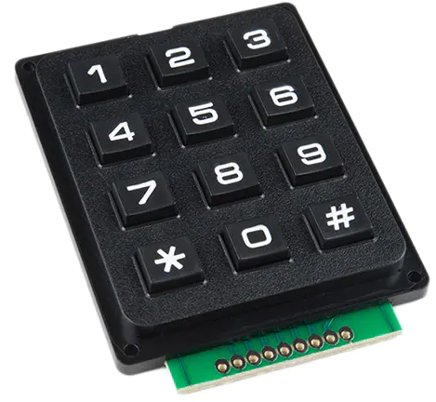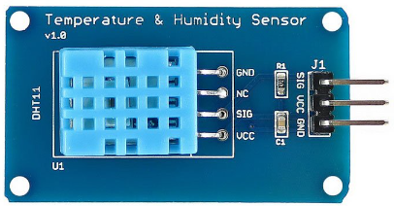

HTML

THS

## Functional Requirements

### Function PIN Code Access

|  |  |
| --- | --- |
| **REQ_ID** | **Requirement** |
| REQ-01 | The front door remains in “LOCKED” state if the PIN Code entered is incorrect. |
| REQ-02 | The front door remains in “LOCKED” state if there is no PIN Code entered. |
| REQ-03 | The front door changes to “UNLOCKED” state if the PIN Code entered is the same as PIN Code 1. |
| REQ-04 | The front door changes to “UNLOCKED” state if the PIN Code entered is the same as Pin Code 2. |
| REQ-05 | The front door changes to “UNLOCKED” state if the PIN Code entered is the same as PIN Code 3. |



The door is in “LOCKED” state

Is PIN Code entered? (Yes/No)

No

Yes

Is the PIN Code entered correct as PIN Code 1, 2 or 3?

No

Yes

The front door switch to “UNLOCKED” state

### Function NFC Card Access

|  |  |
| --- | --- |
| **REQ_ID** | **Requirement** |
| REQ-06 | The front door remains in “LOCKED” state if NFC card tapped is incorrect. |
| REQ-07 | The front door remains in “LOCKED” state if there is no NFC card. |
| REQ-08 | The front door unlocks when a correct NFC card 1 is being tapped. |
| REQ-09 | The front door unlocks when a correct NFC card 2 is being tapped. |
| REQ-10 | The front door unlocks when a correct NFC card 3 is being tapped. |

Start

The front door is in “LOCKED” state

Is there a NFC card tapped (Y/N)?

N

Y

Is the card tapped same as NFC card 1,2 or 3 (Y/N)?

N

Y

The front door will switch to “UNLOCKED” state

END

* + 1. Access

|  |  |
| --- | --- |
| **REQ_ID** | **Requirement** |
| REQ-11 | The internal HTTP server on the AloT Home Automation System shall allow the user to control the following,   * Locking/Unlocking front door. |

2.3.4. Intrusion Detection

|  |  |
| --- | --- |
| **REQ_ID** | **Requirement** |
| REQ-12 | Detects a forced entry when the door is in “LOCKED” state. |
| REQ-13 | Notification should be sent as an alert of intrusion. |
| REQ-14 | LDR sensor that is mounted on the door will tell the user whether it is closed or opened.  If it is closed: “Door is closed”  If it is opened:” Door is opened” |

2.3.5. Remote Access

|  |  |
| --- | --- |
| **REQ_ID** | **Requirement** |
| REQ-15 | The user shall be able to login to the IP address of the AloT Home Automation System to view a HTML page. |
| REQ-16 | The internal HTTP server on the AloT Home Automation System shall allow the user to monitor the following,   * Temperature and Humidity in the House * Front door open/close status |
| REQ-17 | The internal HTTP server on the AloT Home Automation System shall allow the user to control the following,   * Unlocking front door * Lights in all rooms |

## Non-Functional Requirements

|  |  |
| --- | --- |
| **REQ_ID** | **Requirement** |
| REQ-18 |  |
| REQ-19 |  |

# Software Architecture

## Static Software Architecture

**Hal_Keypad.py**

**Hal_HumidtySensor.py**

**NFC**

**Hal_TempSensor.py**

**Hal_LCD.py**

**Hal_LDR.py**

**Hal_Servo.py**

**Hal_ADC.py**

**Hal_LED.py**

**Hardware abstraction layer**

The Software Architecture defines the various Software Components that are developed to realize the implementation of the system requirements.

**Hardware abstraction layer**

**Camera**

**Application Layer**

**Intruder.py**

**THS.py**

**.py**

**HTML**